💊 PharmaEZ — Pharmacy & Healthcare E-Commerce
Phase | Project Planning Phase
Document | Project Planning — Product Backlog, Sprint Planning, Stories, Story Points
Project Name | PharmaEZ — Pharmacy & Healthcare E-Commerce
Team ID | [TEAM-ID]
Date | 14 June 2026
Maximum Marks | 5 Marks

Product Backlog, Sprint Schedule & Estimation

Sprint | Epic (FR) | USN | User Story / Task | Story Points | Priority | Team Members
Sprint 1 | User Registration & Auth | USN-1 | Register via email, name, phone, password | 3 | High | Full Team
Sprint 1 |  | USN-2 | Login with email/password; receive JWT token | 2 | High | Full Team
Sprint 1 |  | USN-3 | Protected routes — JWT verify middleware (protect) | 2 | High | Backend Lead
Sprint 1 |  | USN-4 | Role-based access — adminOnly middleware | 1 | High | Backend Lead
Sprint 1 | Product Catalogue & Search | USN-5 | Product schema with all pharmacy fields (saltComposition, dosageForm, strength, etc.) | 3 | High | Backend Lead
Sprint 1 |  | USN-6 | Product listing API — filters, search (regex), pagination | 3 | High | Backend Lead
Sprint 1 |  | USN-7 | Frontend ProductsPage with sidebar filters, sort, pagination | 3 | High | Frontend Lead
Sprint 1 |  | USN-8 | ProductCard component — image, badges, price, Add to Cart | 2 | High | Frontend Lead
Sprint 1 | Product Detail | USN-9 | ProductDetailPage — gallery, clinical info, Rx notice, reviews tab | 3 | High | Frontend Lead
Sprint 1 |  | USN-10 | Product CRUD admin API (create, update, delete) | 2 | High | Backend Lead
Sprint 1 |  | USN-11 | AdminProducts page — searchable paginated table | 2 | High | Frontend Lead
Sprint 1 |  | USN-12 | AdminProductForm — 4-section create/edit form | 3 | High | Frontend Lead
Sprint 2 | Shopping Cart | USN-13 | Cart model + cartController (add, update, remove, clear) | 3 | High | Backend Lead
Sprint 2 |  | USN-14 | CartPage — items, Rx notice, shipping bar, GST summary | 3 | High | Frontend Lead
Sprint 2 |  | USN-15 | CartContext — global cart state, cartCount, cartSubtotal | 2 | High | Frontend Lead
Sprint 2 | Checkout & Orders | USN-16 | 3-step CheckoutPage (Address → Payment → Review) | 3 | High | Frontend Lead
Sprint 2 |  | USN-17 | Order API — placeOrder (stock deduct, loyalty pts, Rx status) | 4 | High | Backend Lead
Sprint 2 |  | USN-18 | Order cancellation with stock restoration | 2 | Medium | Backend Lead
Sprint 2 |  | USN-19 | Order confirmation page with order number | 1 | High | Frontend Lead
Sprint 2 |  | USN-20 | 5-step order tracking visual progress component | 2 | High | Frontend Lead
Sprint 2 | Prescriptions | USN-21 | Prescription upload API — Multer, file storage, user.prescriptions[] | 3 | High | Backend Lead
Sprint 2 |  | USN-22 | PrescriptionsPage — upload form + prescription list with status | 2 | High | Frontend Lead
Sprint 2 | Admin — Orders | USN-23 | AdminOrders page — filter pills, inline status dropdown, detail panel | 3 | High | Frontend Lead
Sprint 2 |  | USN-24 | Admin order status update API with statusHistory[] audit trail | 2 | High | Backend Lead
Sprint 2 | Admin — Prescriptions | USN-25 | AdminPrescriptions page — review queue, image preview, approve/reject | 3 | High | Frontend Lead
Sprint 2 |  | USN-26 | Admin prescription review API (approve/reject) | 2 | High | Backend Lead
Sprint 3 | Reviews & Ratings | USN-27 | Add review API — 1 per user per product; aggregate recalculation | 2 | Medium | Backend Lead
Sprint 3 |  | USN-28 | Reviews tab on ProductDetailPage — form + list | 2 | Medium | Frontend Lead
Sprint 3 | Loyalty Points | USN-29 | Loyalty points award on order delivery (1pt/₹10) | 1 | Medium | Backend Lead
Sprint 3 |  | USN-30 | Loyalty points display in UserDashboard | 1 | Medium | Frontend Lead
Sprint 3 | Wishlist | USN-31 | Wishlist toggle API + WishlistPage | 2 | Medium | Full Team
Sprint 3 | Admin — Inventory | USN-32 | Inventory report API — by-category, low-stock | 2 | High | Backend Lead
Sprint 3 |  | USN-33 | AdminInventory page — summary cards, low-stock alerts | 2 | High | Frontend Lead
Sprint 3 | Admin — Dashboard | USN-34 | Dashboard stats API — MongoDB aggregation (revenue, KPIs, 7-day chart) | 3 | High | Backend Lead
Sprint 3 |  | USN-35 | AdminDashboard page — KPI cards, revenue bar chart, recent orders | 3 | High | Frontend Lead
Sprint 3 | Admin — Users | USN-36 | AdminUsers page — list, search, activate/deactivate | 2 | High | Full Team
Sprint 4 | Profile Management | USN-37 | Profile update, change password, address management | 2 | Medium | Full Team
Sprint 4 |  | USN-38 | ProfilePage and address management UI | 2 | Medium | Frontend Lead
Sprint 4 | Store Config | USN-39 | Admin config API (shipping threshold, tax rate, banners) | 2 | Medium | Backend Lead
Sprint 4 |  | USN-40 | AdminConfig management UI | 1 | Low | Frontend Lead
Sprint 4 | Seeder & Testing | USN-41 | Database seeder (12 sample products, admin user, sample user) | 2 | High | Backend Lead
Sprint 4 |  | USN-42 | End-to-end integration testing and bug fixes | 4 | High | Full Team
Sprint 4 | Deployment | USN-43 | Production build, environment config, deployment to Railway/Render | 3 | High | Full Team

Total Story Points Summary
Sprint | Story Points | Focus Area | Priority Level
Sprint 1 | 38 points | Auth, Product Catalogue, Admin Product CRUD | Critical / Must Have
Sprint 2 | 42 points | Cart, Checkout, Orders, Prescriptions, Admin Orders/Rx | Critical / Must Have
Sprint 3 | 20 points | Reviews, Loyalty, Wishlist, Inventory, Admin Dashboard | Should Have
Sprint 4 | 16 points | Profile, Config, Seeder, Testing, Deployment | Should Have / Nice to Have
TOTAL | 116 points | Full PharmaEZ MVP | 4-Sprint Delivery

Project Tracker, Velocity & Burndown Chart

Sprint | Total Story Points | Duration | Sprint Start Date | Sprint End Date (Planned) | Story Points Completed (as on Planned End Date) | Sprint Release Date (Actual)
Sprint 1 | 38 | 6 Days | Week 1 Day 1 | Week 1 Day 6 | 38 | Week 1 Day 6
Sprint 2 | 42 | 6 Days | Week 2 Day 1 | Week 2 Day 6 | 42 | Week 2 Day 6
Sprint 3 | 20 | 6 Days | Week 3 Day 1 | Week 3 Day 6
Sprint 4 | 16 | 6 Days | Week 4 Day 1 | Week 4 Day 6

Velocity Calculation
Metric | Value | Calculation / Notes
Total Story Points | 116 points | Across 4 sprints covering all MVP features
Total Sprint Duration | 24 days (4 × 6 days) | Each sprint is 6 working days
Target Velocity (points/sprint) | 29 points/sprint | 116 total ÷ 4 sprints = 29 points per sprint
Average Velocity per Day | ~4.8 points/day | 29 points ÷ 6 days = 4.83 points per working day
Sprint 1 Actual Velocity | 38 points | Higher due to foundational architecture work yielding reusable patterns for subsequent sprints
Sprint 2 Planned Velocity | 42 points | Highest sprint — core business logic (orders, prescriptions, checkout)

Burndown Chart Description
A burndown chart represents work remaining (story points) versus time. Below is the ideal and expected trajectory for the PharmaEZ 4-sprint plan:

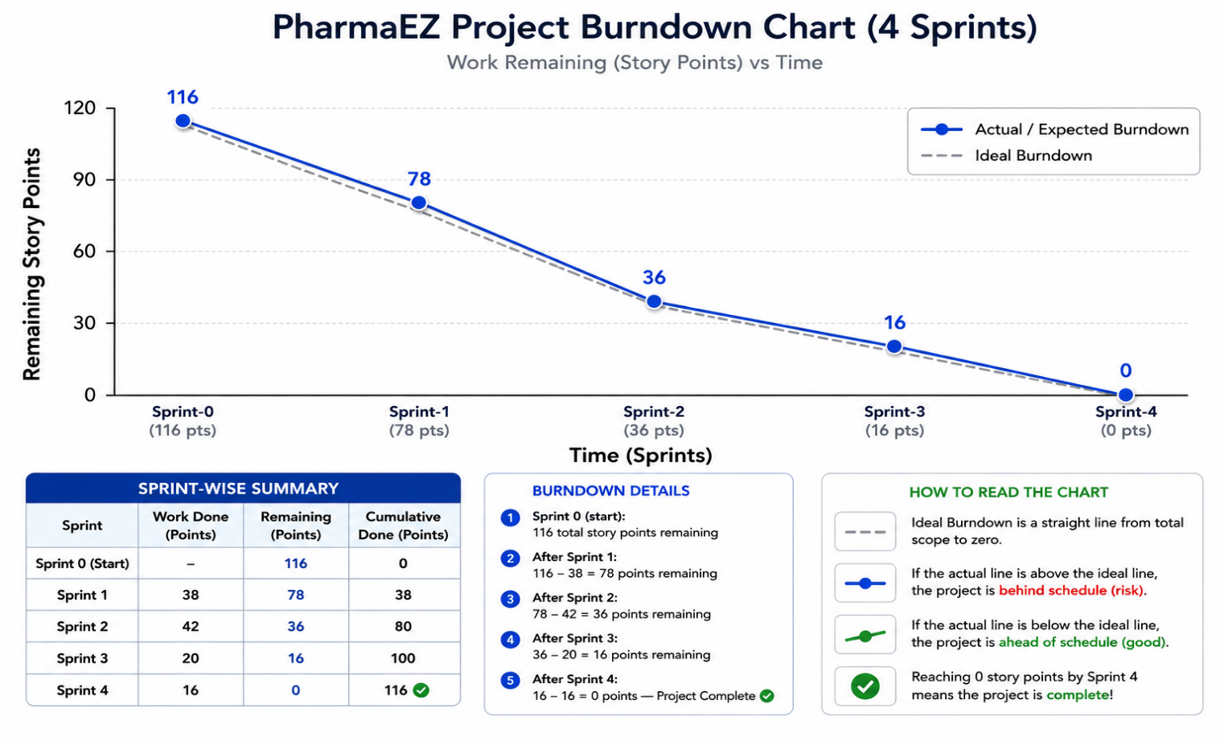
- Sprint 0 (start): 116 total story points remaining
- After Sprint 1: 116 – 38 = 78 points remaining
- After Sprint 2: 78 – 42 = 36 points remaining
- After Sprint 3: 36 – 20 = 16 points remaining
- After Sprint 4: 16 – 16 = 0 points — Project Complete ✅

